INTRODUCING SELF

Learning Objectives:
After following the learning process, the students are able to:
- Identify pronoun used in the dialogue of Introducing self.
- Write the dialogue using the correct pronoun

Activity 1: Fill in the blanks with the right pronouns.
- I (Me/I) come to Yogyakarta every month.
- I am going to introduce HER (she/her) to my parents.
- WE (we/ours) plan to visit Thailand next year.
- Lolita told ME (we/me) that she wanted to send the letter to her pen pal
- I am going to wash MY (my/me) hand
- Do you like YOUR (you/your) meal today?
- HE (His/He) Spends the weekend playing guitar.
- WE (we/it) can climb Bromo Mountain together on July.
- HER (her/she) Hobby is playing guitar and listening to music.
- Rendy had many e-pals and he always keep in touch with THEM (them/their)

Activity 2: Read the text bellow then answer the questions.
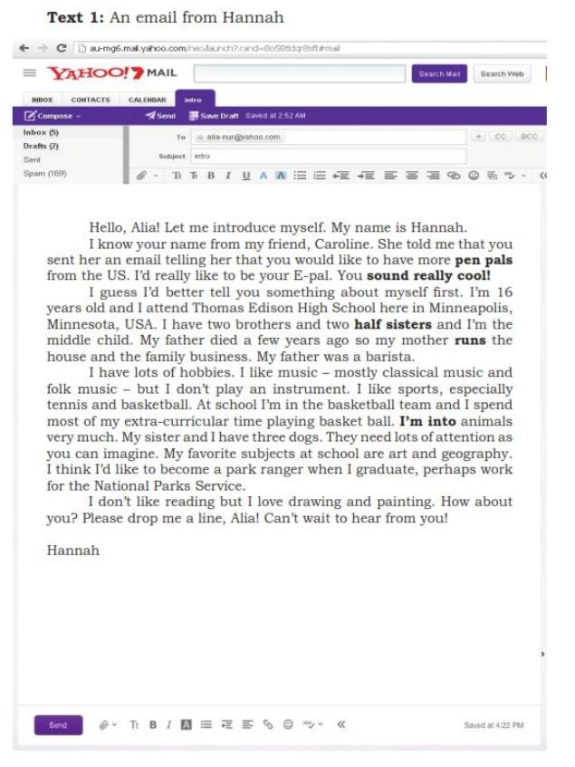
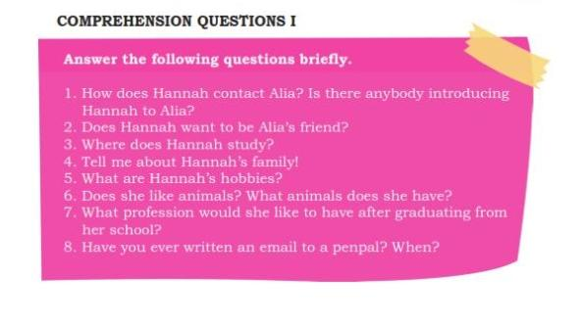

Listen to the Audio then fill the blanks in the dialog.
Dialog 1
Yudi is at the cinema waiting for the film on air. He sees one seat vacant and approaches the boy sitting next to it.
Yudi : Excuse me. (1) …may I sit here……..?
Vito : Yes, sure.
Yudi : Thanks. By the way, I’m Yudi. May I know your name, please?
Vito : Hi, Yudi. I’m Vito.
Yudi : Nice to meet you, Vito.
Vito : Nice to meet you too, Yudi.
Yudi : Err … (2) ……where do you study……….., Vito?
Vito : I study at SMAN 1.
Yudi : SMAN 1? (3) …I study there too…………..
Vito : What a coincidence! (4)……what class are you from…………? I’m from Class XE.
Yudi : I’m from Class XB. By the way, do you know Erlita?
Vito : Yes, I know her. She sits in front of me. (5) …how do you know her…………..?
Yudi : She is my neighbor.

Dialog 2
Erna and Entin are chatting while enjoying their drinks when Yudi passes by.
Erna : Hi, Yudi!
Yudi : Hi, Erna! Hello, Entin.
Entin : Hello, Yudi. Please join us here.
Yudi : (1) ……sure thanks……. By the way, is this seat vacant?
Erna : (2)…yes, please have a seat……….. So, how’s everything with you, Yudi?
Yudi : Everything is just fine. (3) ……I hope both of you are okay……….
Erna : We are, thanks.
Yudi : Well, may I know what you are talking about?
Erna : Sure. We’re talking about our friends from junior high school.
Yudi : (4) ……have you met them………..?
Entin : Yes. (5………we met them yesterday……….. We’re happy we’re

